COMPUTER NETWORK PRACTICUM REPORT
Introduction to Cisco Packet Tracer


Lecturer:
Dimas Novian Aditia Syahputra, S. Tr. T., M. Tr. T.
Prepared by:
Name: Aisyah Currents
NIM (Student id): 25091397108
Class: International

UNIVERSITAS NEGERI SURABAYA
FACULTY OF VOCATION
INFORMATICS MANAGEMENT STUDY PROGRAM
YEAR 2025

- Short report about the result exploring Cisco Packet Tracer Interface
Short report is on the other file, or you can access by link on the below:
https://rentsaisy.github.io/Cisco-Packet-Tracer-Exploration/
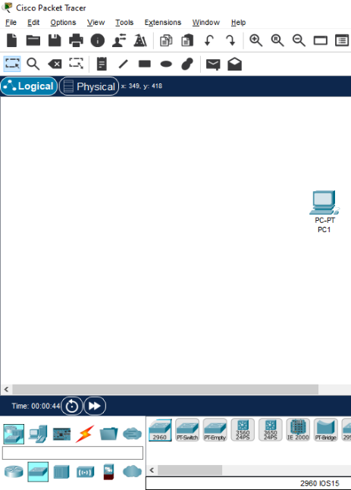
- Making a simple network topology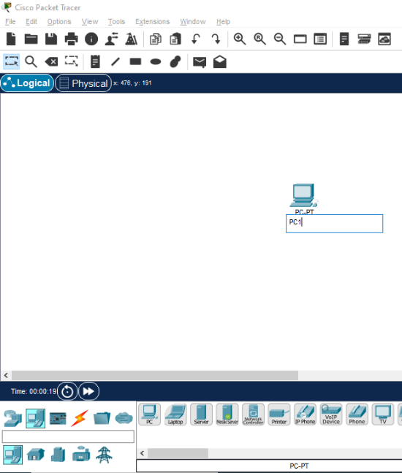
To create a simple topology with two PCs and one switch, start by selecting the End Devices category to place the PCs, and then choose the Network Devices category to add a switch. If you want to rename any device, simply click on its label and type in the new name. For this setup, name the devices as PC1, PC2, and SW1.
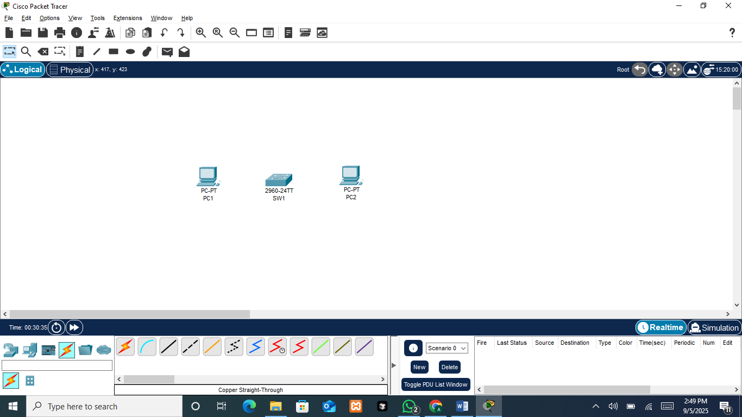
After placing all the required devices in the workspace area, go to the Connections category and choose a copper straight-through cable. Why a copper straight-through? Because it is used to connect two different types of devices. In this case, from PC1 to SW1, and then from SW1 to PC2.
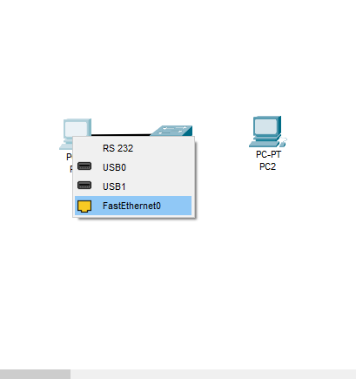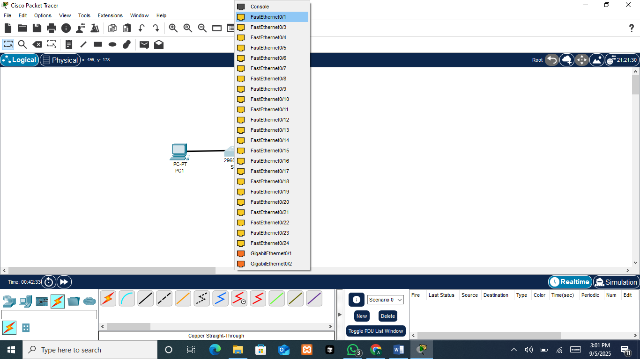
After selecting the copper straight-through cable, the connection is made through the appropriate ports. On the PC1, the FastEthernet0 port is selected. This port acts as the network interface card (NIC) of the PC1, allowing it to send and receive data over the network. On the SW1, one of the available FastEthernet interfaces (for example, FastEthernet0/1) is chosen. These switch ports are designed to forward data between connected devices, making them the central point of communication in the local network.
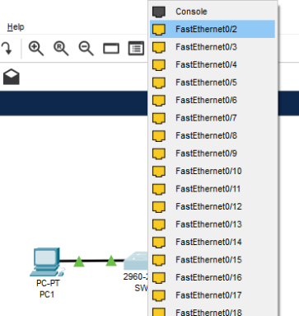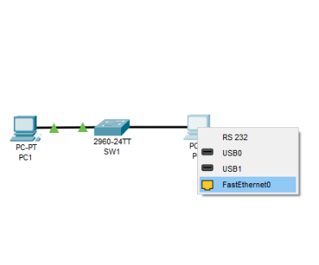
Repeat the same steps for the second PC: connect from FastEthernet0 on PC2 to another port on the switch, such as FastEthernet0/2. This way, both PCs are properly connected to the switch, allowing them to communicate within the same network.
- Basic IP Address Configuration
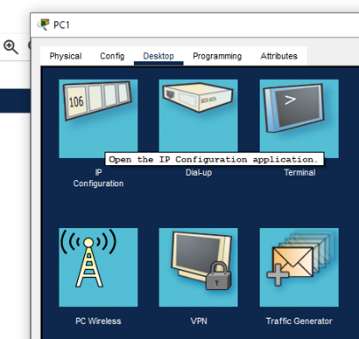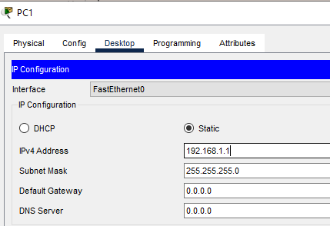
To create a basic configuration, open PC1, go to the menu, and select IP Configuration. In the IP configuration window, enter the IP address in IPv4 Address. For example, type 192.168.1.1. Once the IP address is entered, the Subnet Mask field will automatically fill in with 255.255.255.0, which indicates that the network portion of the address has been recognized and assigned correctly.
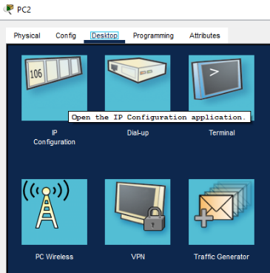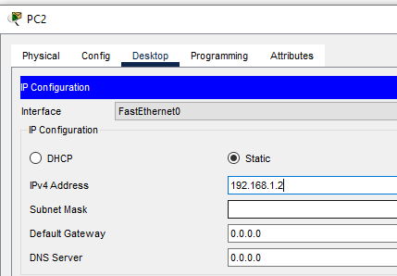
Repeat the same process for PC2. Open the device, go to IP Configuration, and assign another IP address within the same network, such as 192.168.1.2. Again, the Subnet Mask will automatically appear as 255.255.255.0, ensuring that both PCs are on the same subnet and can communicate with each other through the switch.
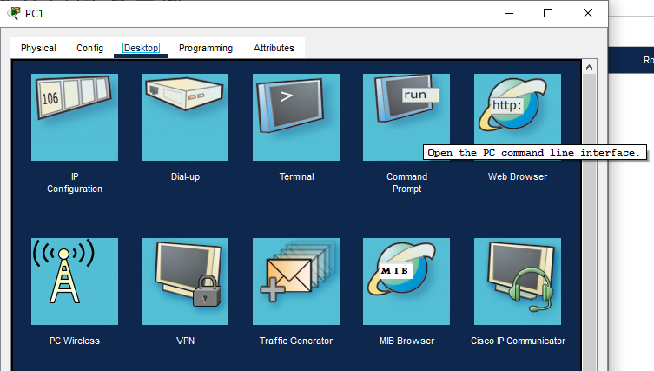
To verify whether the configuration is successful, go to the Desktop tab and open the Command Prompt. The Command Prompt serves as a testing tool where network commands can be executed, such as the ping command, to check connectivity between devices.
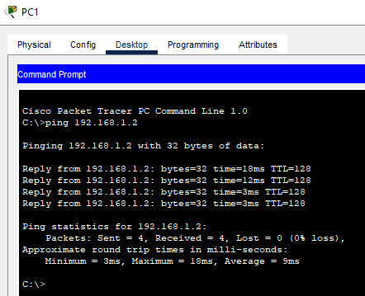
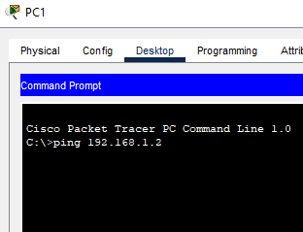
On PC1, the command ping 192.168.1.2 was executed to test connectivity with PC2. The result shows four successful replies with 0% packet loss, round-trip times between 3–18 ms, and TTL = 128, confirming that the connection is working properly.
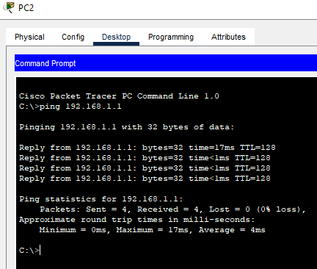
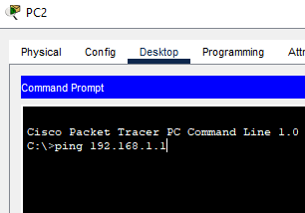

On PC2, the command ping 192.168.1.1 was executed to test connectivity with PC1. The result shows four successful replies with 0% packet loss, round-trip times between 0–17 ms, and TTL = 128, confirming that the connection is working properly.
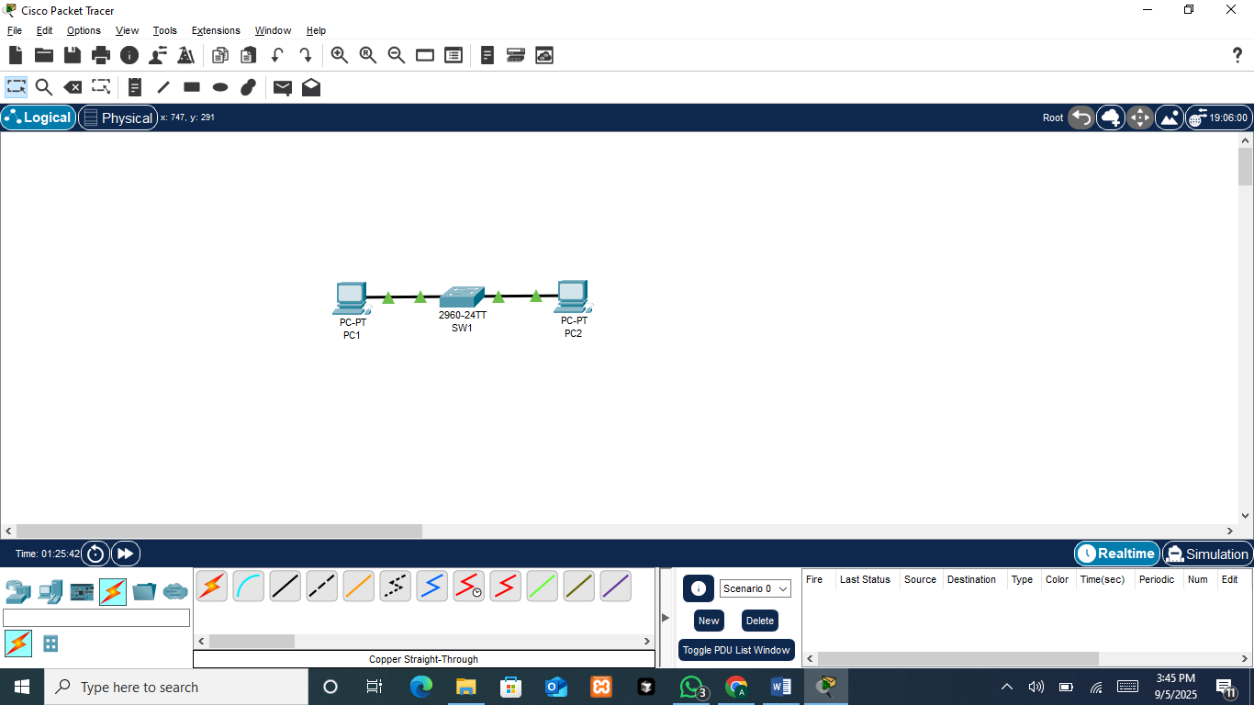
The ping tests from PC1 to PC2 and from PC2 to PC1 were both succesful, with four replies received in each case and 0% packet loss. The round-trip times were minimal, and the TTL values confirmed proper communication within the same local network. These results verify that the devices were correctly configured, connected through the switch, and able to communicate with each other without issues.

